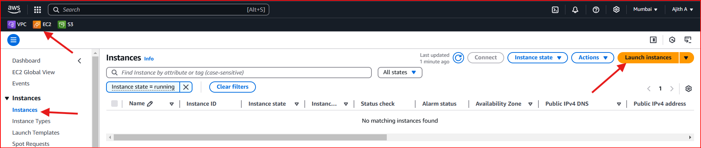

EC2 VM 1

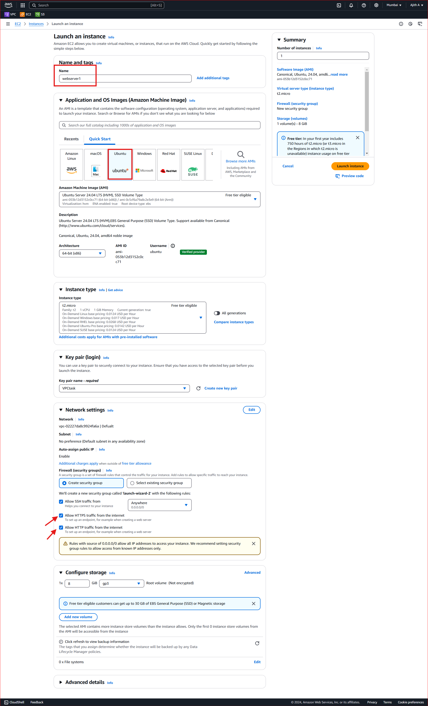

EC2 VM 2

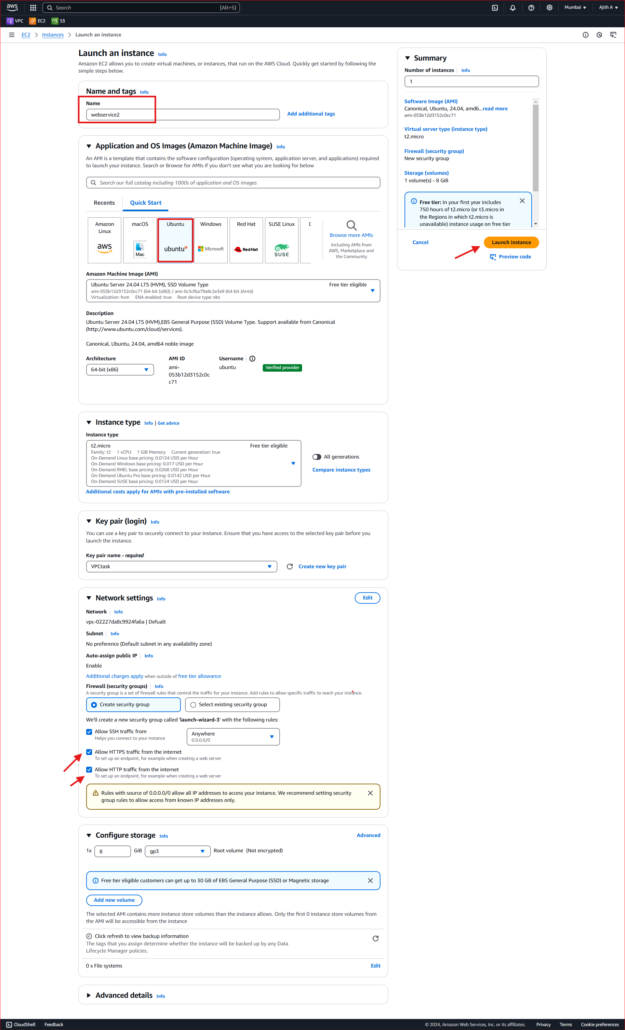

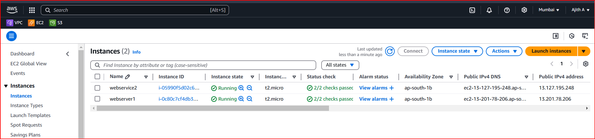

Install Apach2 server

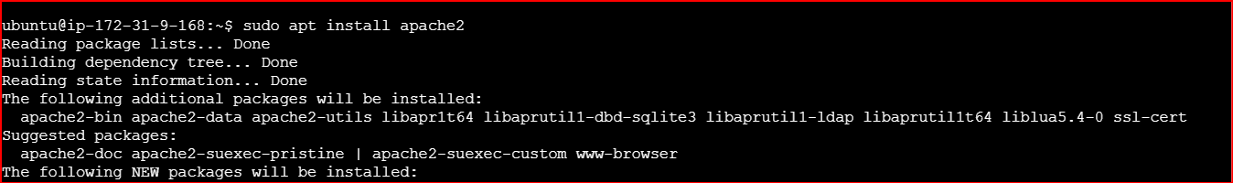

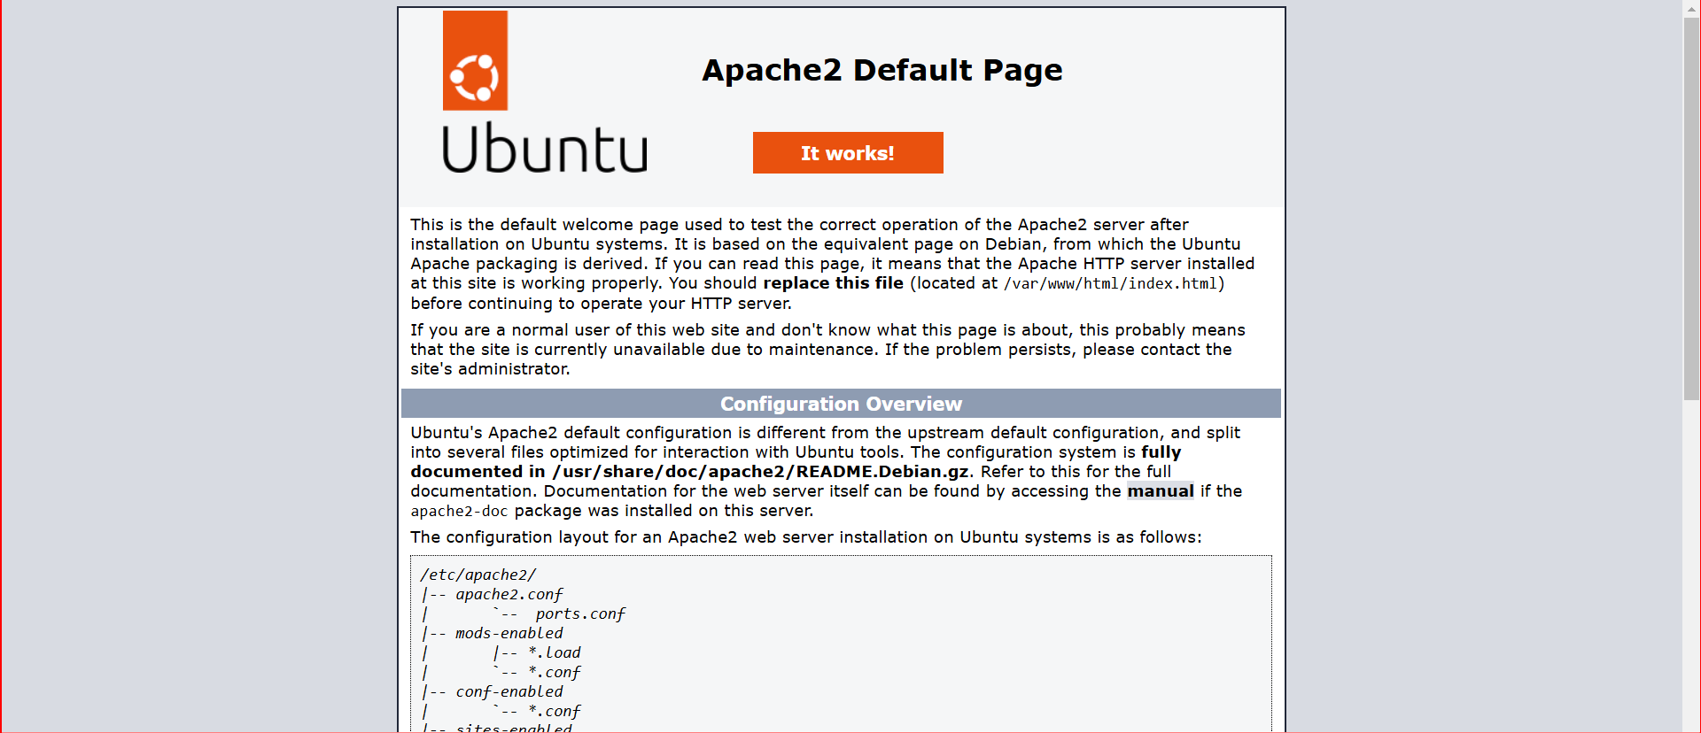

ubuntu@ip-172-31-9-168:~$ **cd var/www**

-bash: cd: var/www: No such file or directory

ubuntu@ip-172-31-9-168:~$ **cd /var/www/**

ubuntu@ip-172-31-9-168:/var/www$ **ls**

**html**

ubuntu@ip-172-31-9-168:/var/www$ **sudo mkdir app**

ubuntu@ip-172-31-9-168:/var/www$ **ls**

**app html**

ubuntu@ip-172-31-9-168:/var/www$ **la -l**

total 8

drwxr-xr-x 2 root root 4096 Dec 6 16:12 app

drwxr-xr-x 2 root root 4096 Dec 6 16:09 html

ubuntu@ip-172-31-9-168:/var/www$ **sudo chown -R www-data:www-data /var/www**

ubuntu@ip-172-31-9-168:/var/www$ **ls -l**

total 8

drwxr-xr-x 2 www-data www-data 4096 Dec 6 16:12 app

drwxr-xr-x 2 www-data www-data 4096 Dec 6 16:09 html

ubuntu@ip-172-31-9-168:/var/www$ cd app

ubuntu@ip-172-31-9-168:/var/www/app$ sudo nano index.html

ubuntu@ip-172-31-9-168:/var/www/app$ cat index.html

**<!DOCTYPE html>**

**<html>**

**<head>**

**<title>First Web Page</title>**

**</head>**

**<body>**

**Hello World!**

**</body>**

**</html>**

ubuntu@ip-172-31-9-168:/etc/apache2/sites-available$ **sudo nano app.conf**

**<VirtualHost *:80>**

**# Primary domain**

**ServerName test-alb-1029540300.ap-south-1.elb.amazonaws.com**

**# Additional domain names or subdomains**

**ServerAlias 13.201.78.206**

**DocumentRoot /var/www/html**

**Alias /app /var/www/app**

**<Directory /var/www/app>**

**Options Indexes FollowSymLinks**

**AllowOverride All**

**Require all granted**

**</Directory>**

**ErrorLog ${APACHE_LOG_DIR}/app_error.log**

**CustomLog ${APACHE_LOG_DIR}/app_access.log combined**

**</VirtualHost>**

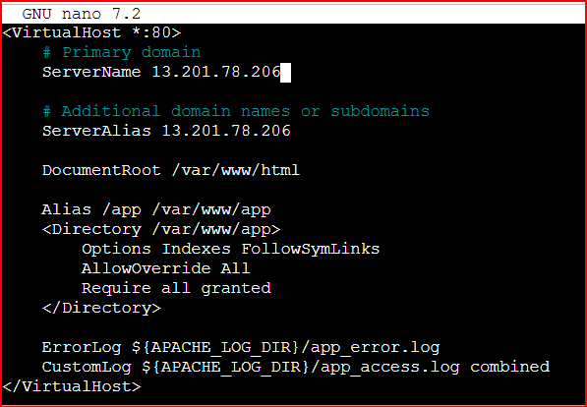

ubuntu@ip-172-31-9-168:/etc/apache2/sites-available$ sudo systemctl reload apache2

ubuntu@ip-172-31-9-168:/etc/apache2/sites-available$ sudo nano app.conf

ubuntu@ip-172-31-9-168:/etc/apache2/sites-available$ sudo a2ensite app.conf

Enabling site app.

To activate the new configuration, you need to run:

systemctl reload apache2

ubuntu@ip-172-31-9-168:/etc/apache2/sites-available$ sudo systemctl reload apache2

ubuntu@ip-172-31-9-168:/etc/apache2/sites-available$ sudo a2ensite app.conf

Site app already enabled

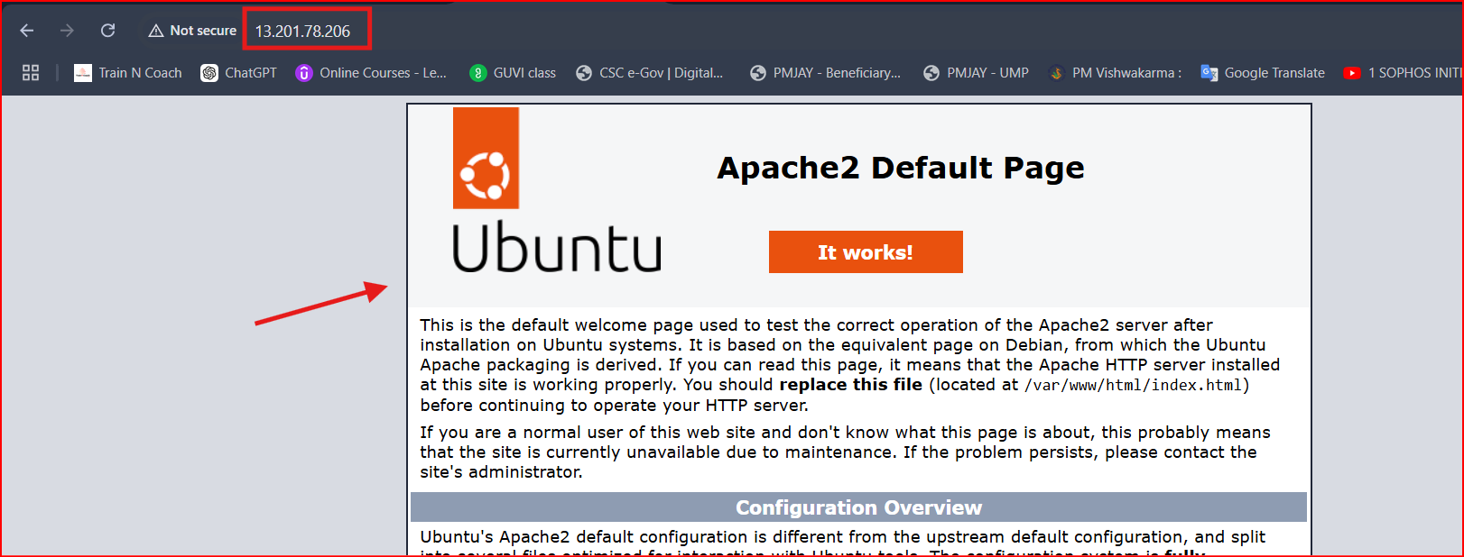

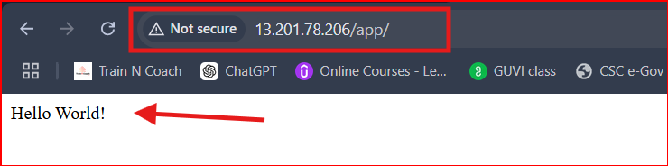

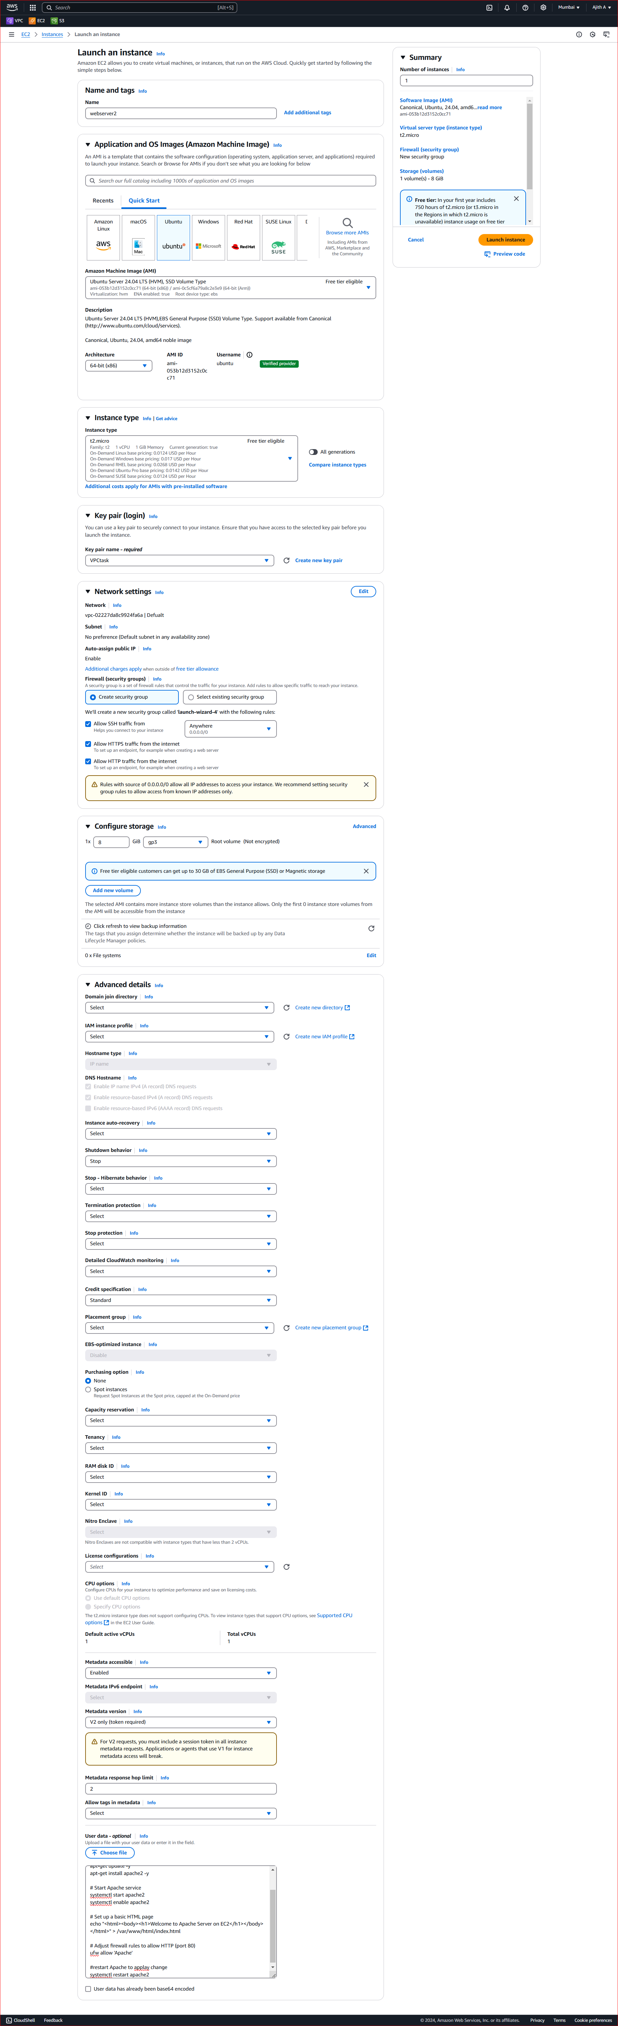

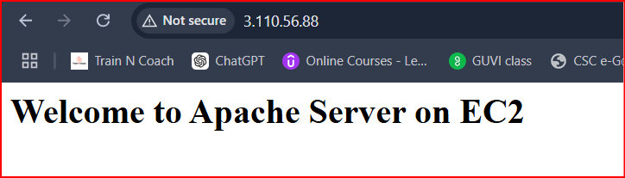

Now create **load balancer**

**1.** Create a Target Group

**2.** Setup an Application Load Balancer (ALB)

3. Configure Outbound Traffic

**1. Create a Target Group**

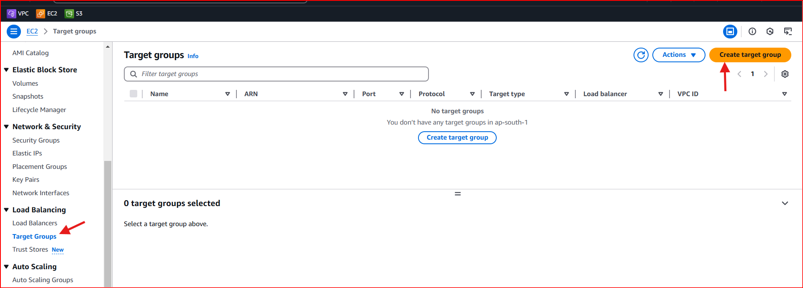

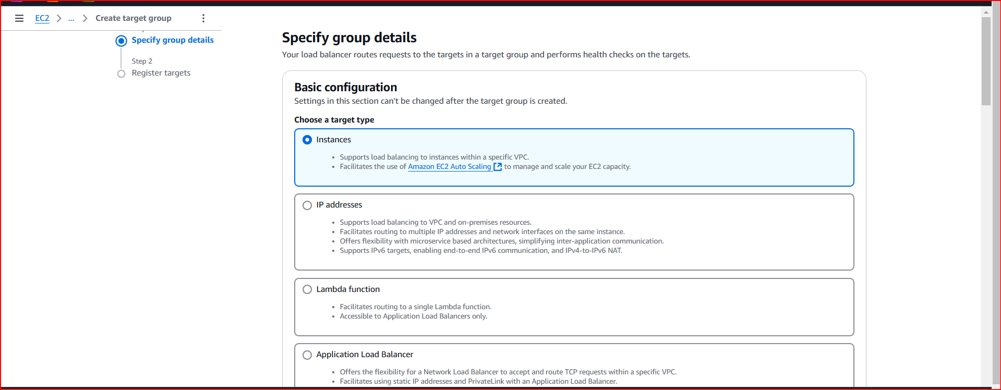

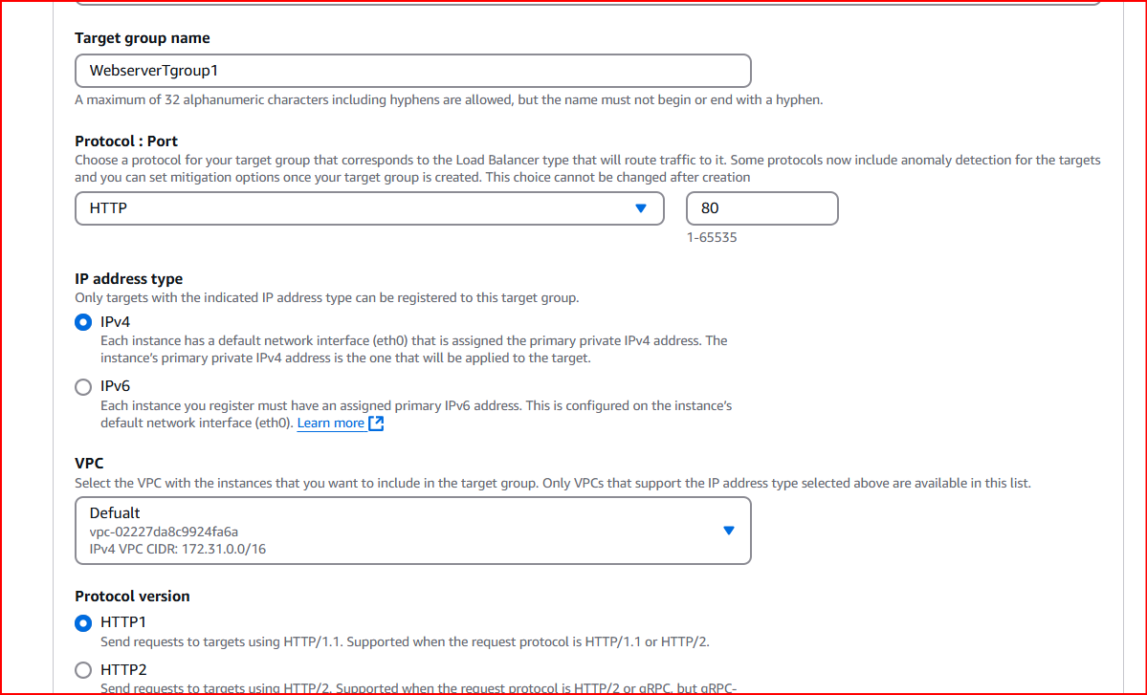

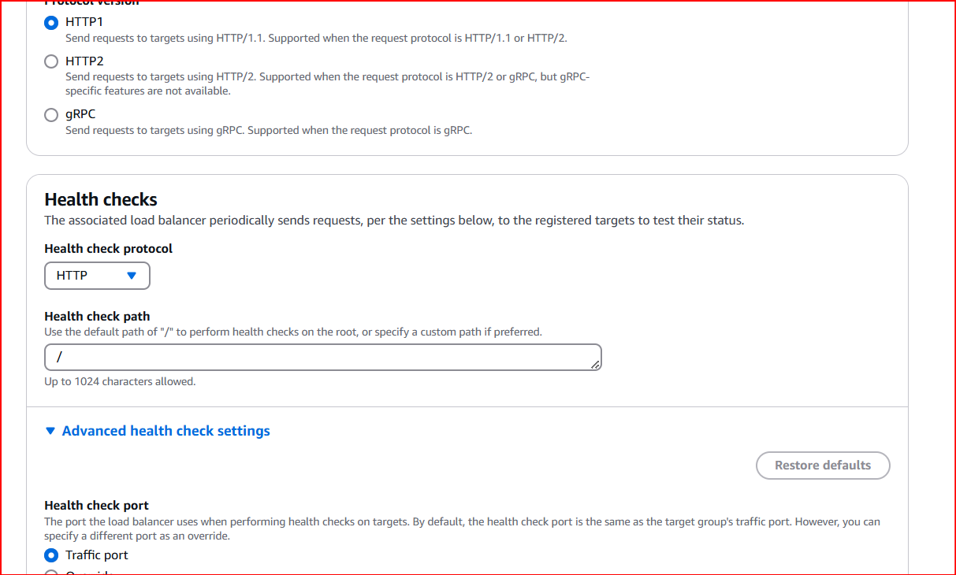

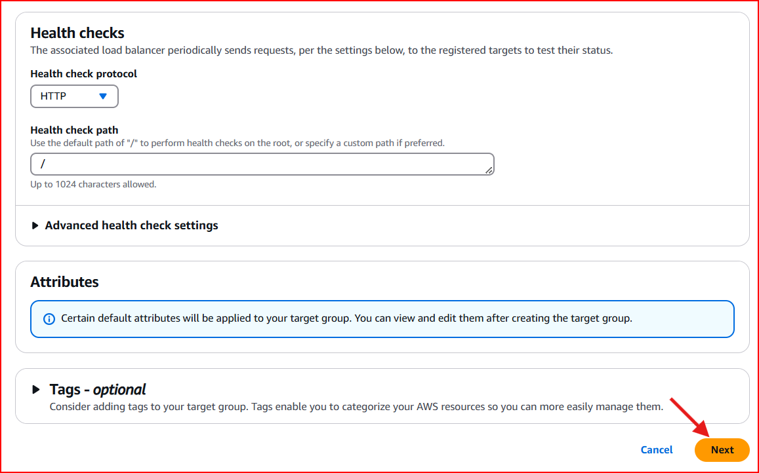

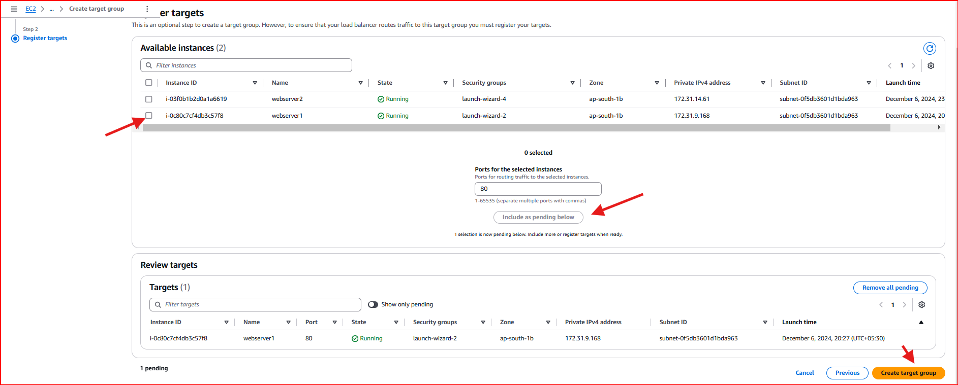

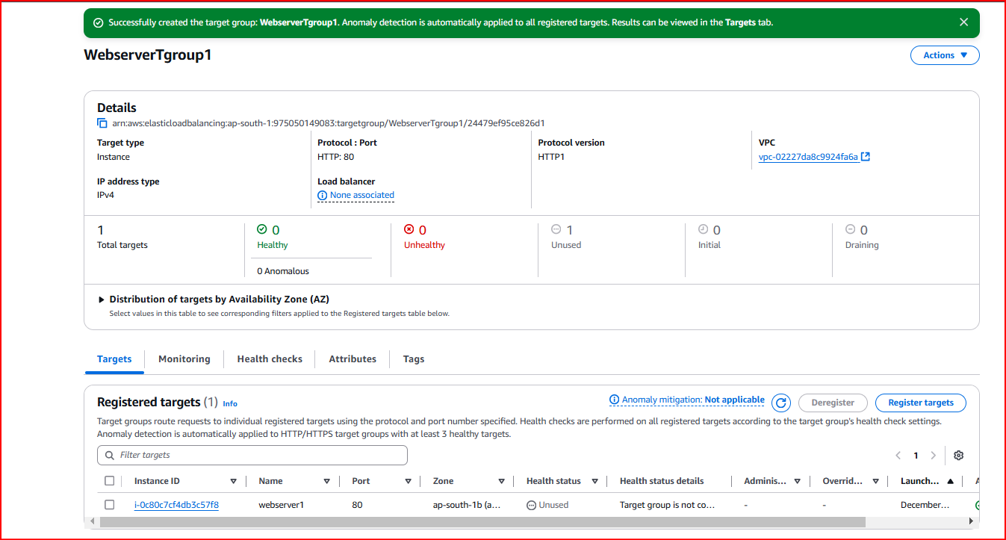

**Crate second server target group**

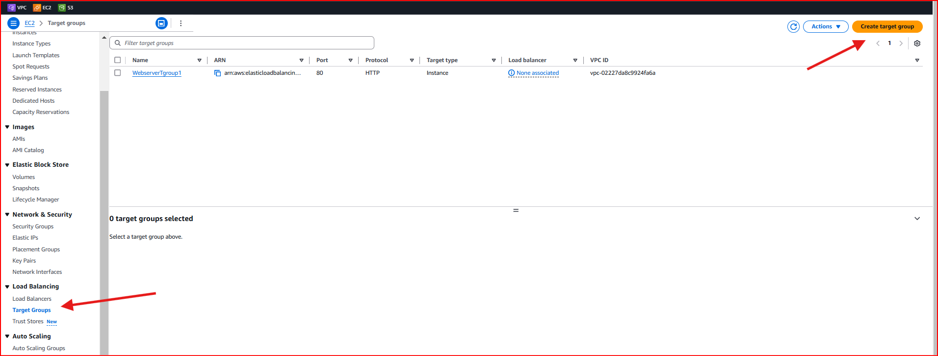

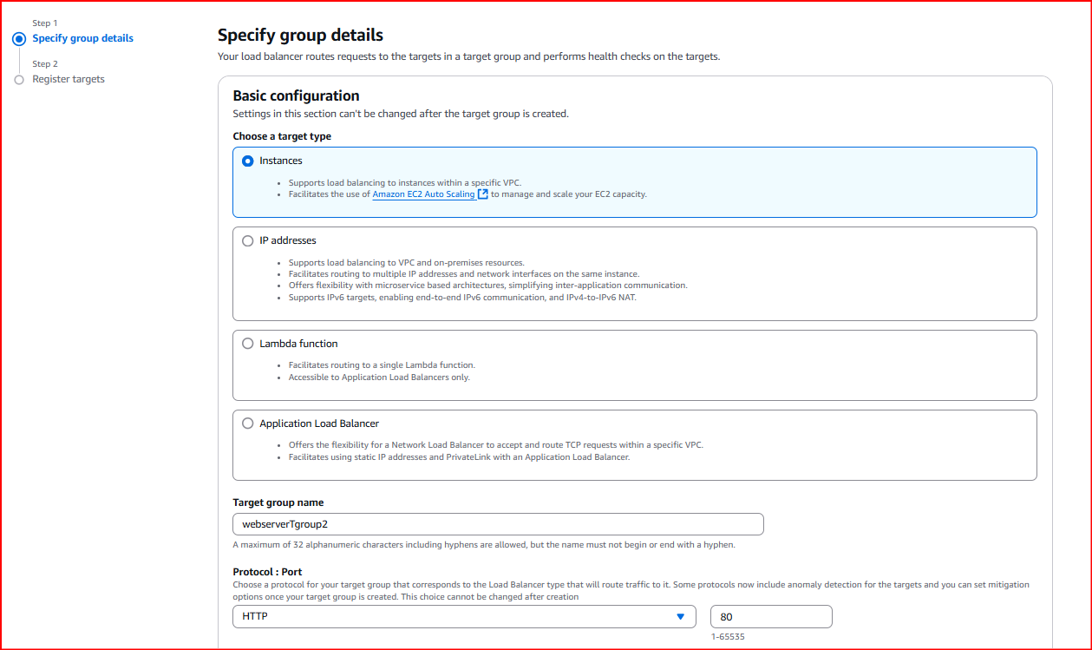

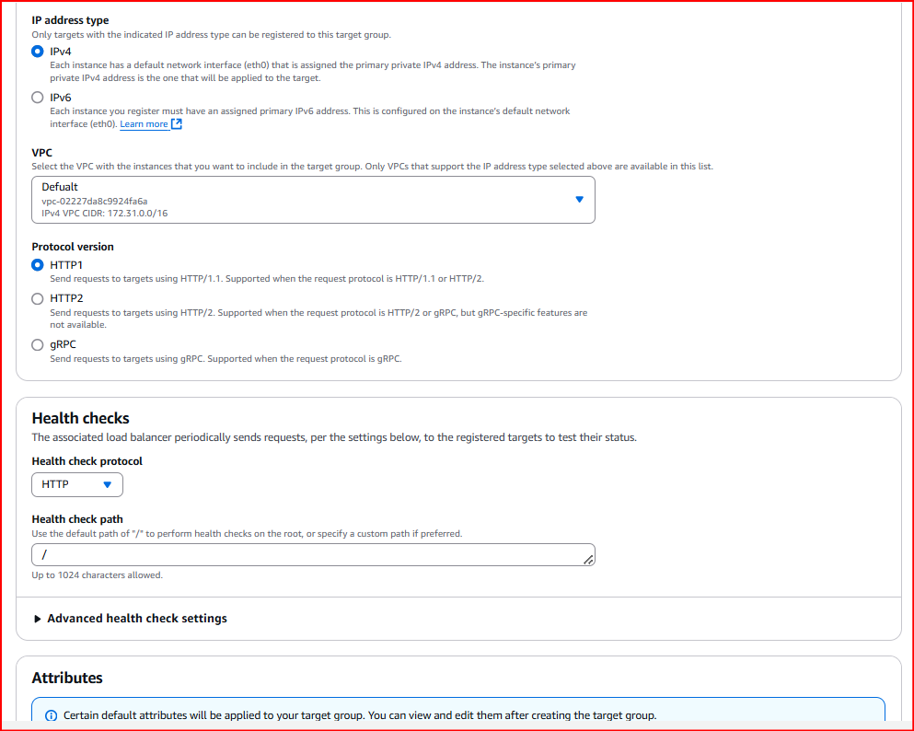

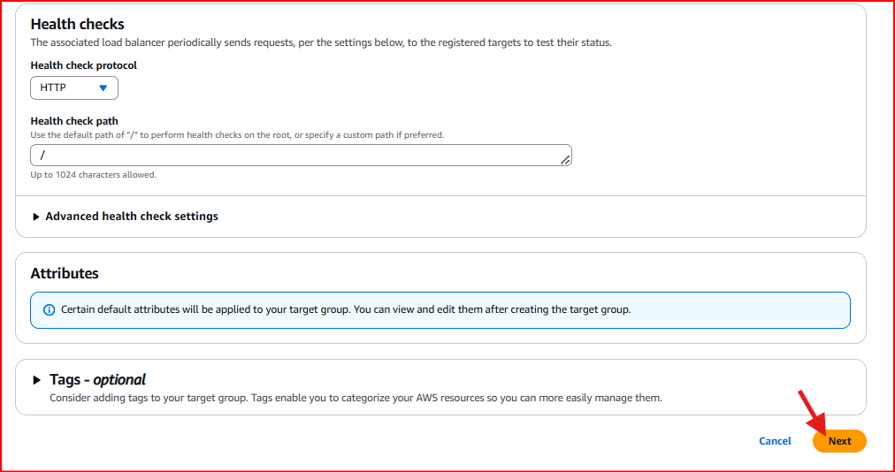

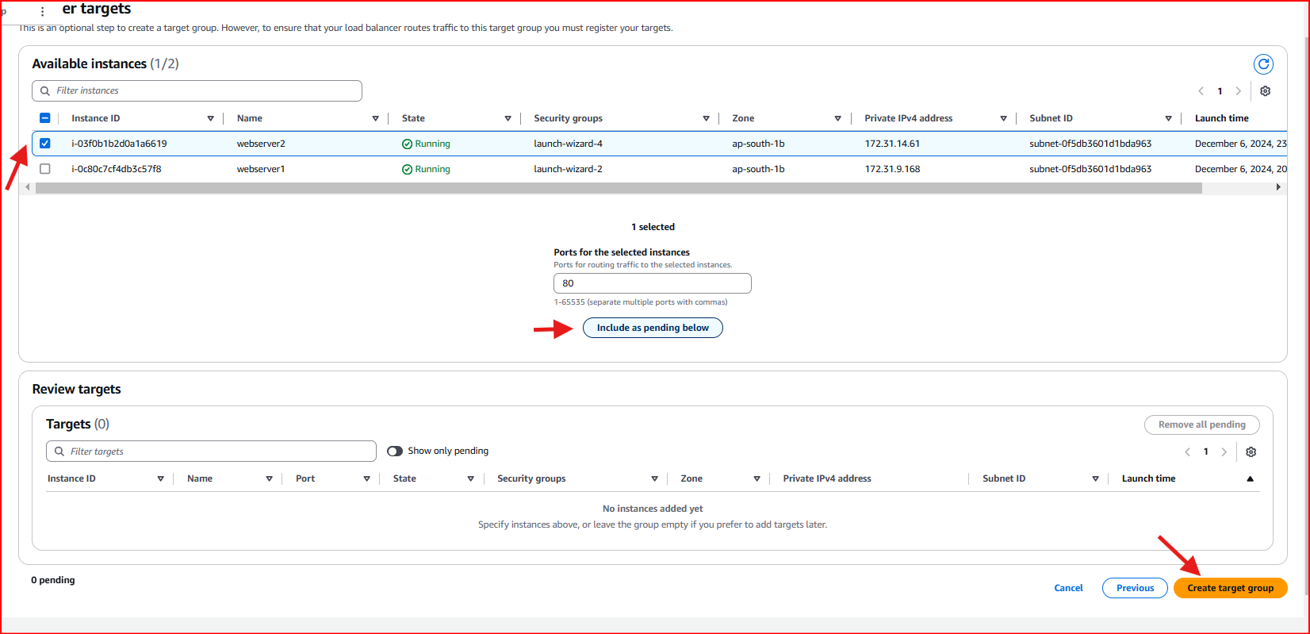

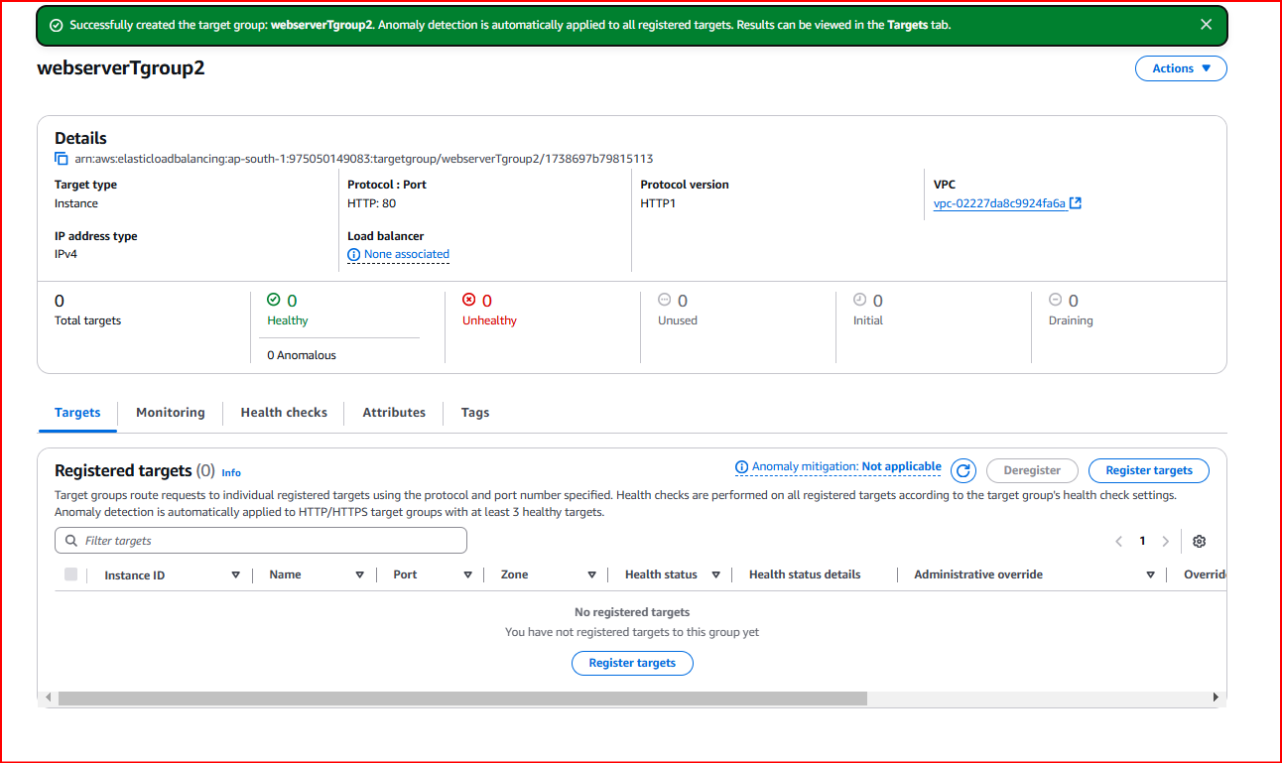

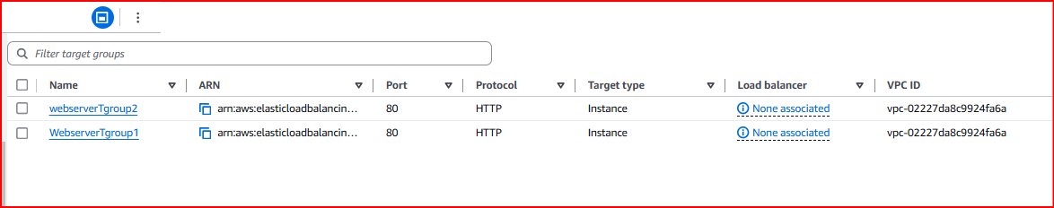

Next create load balancer

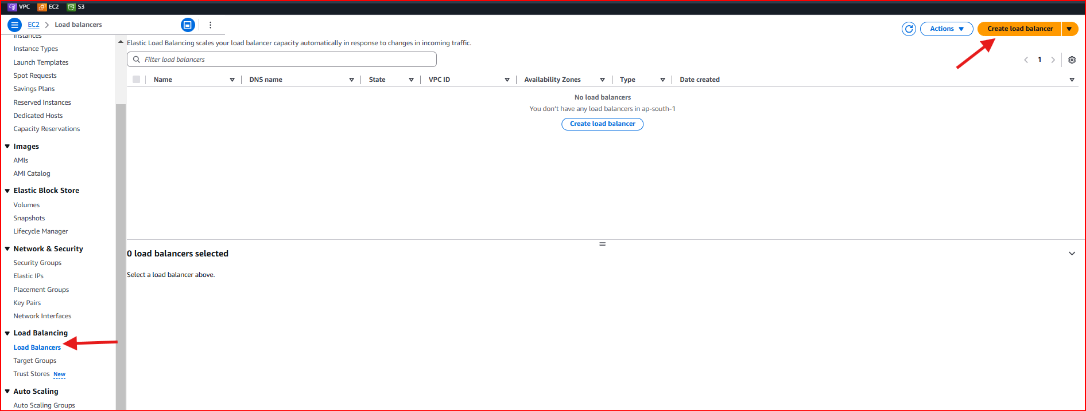

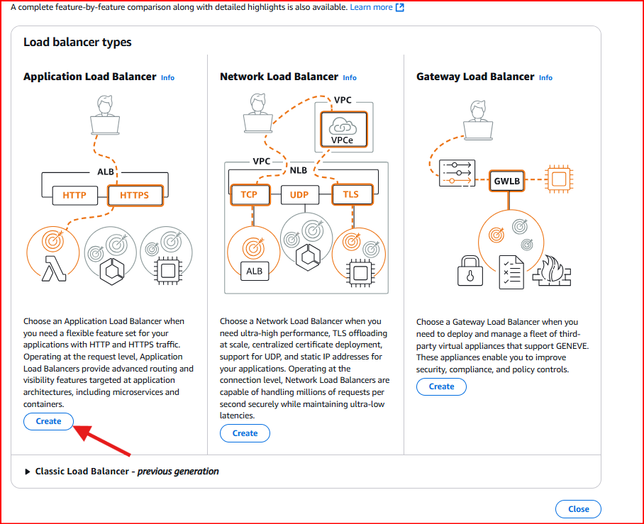

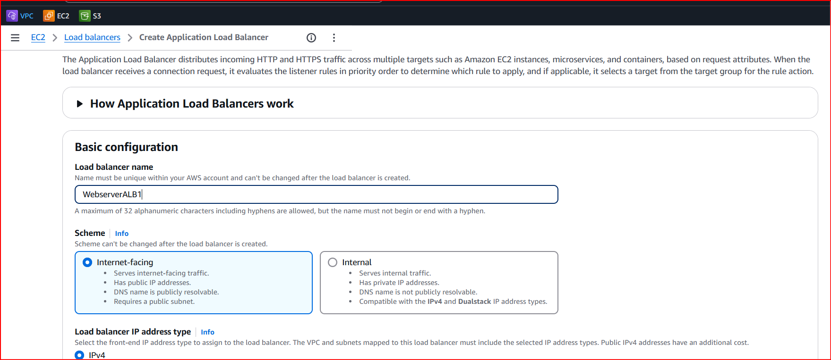

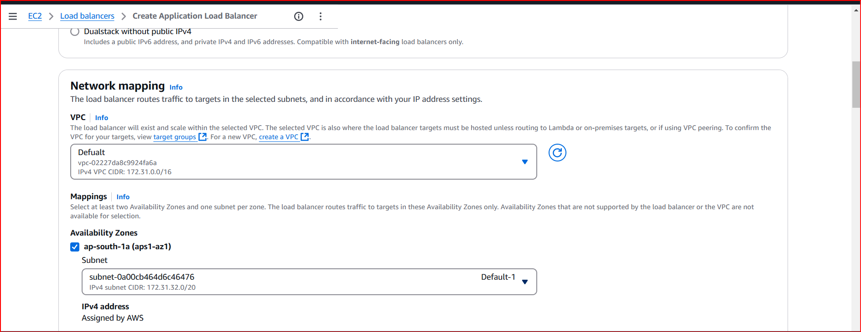

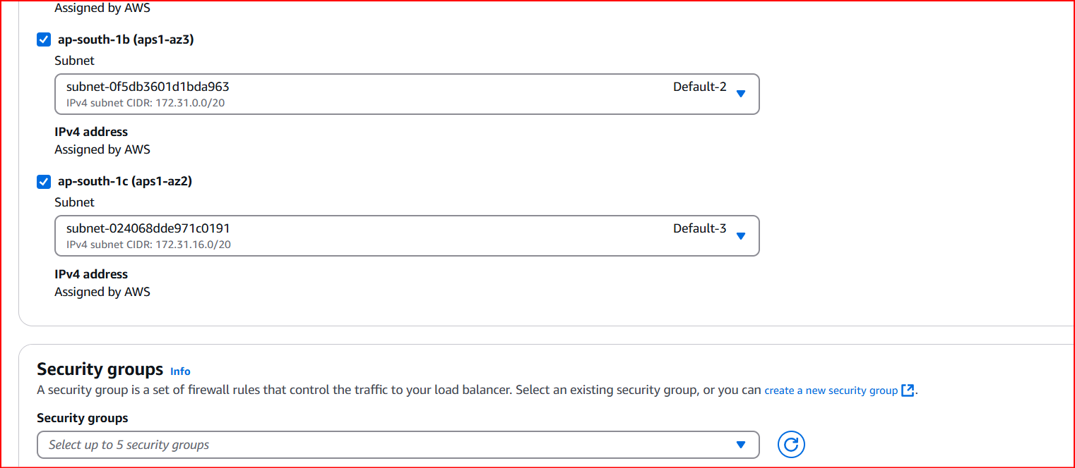

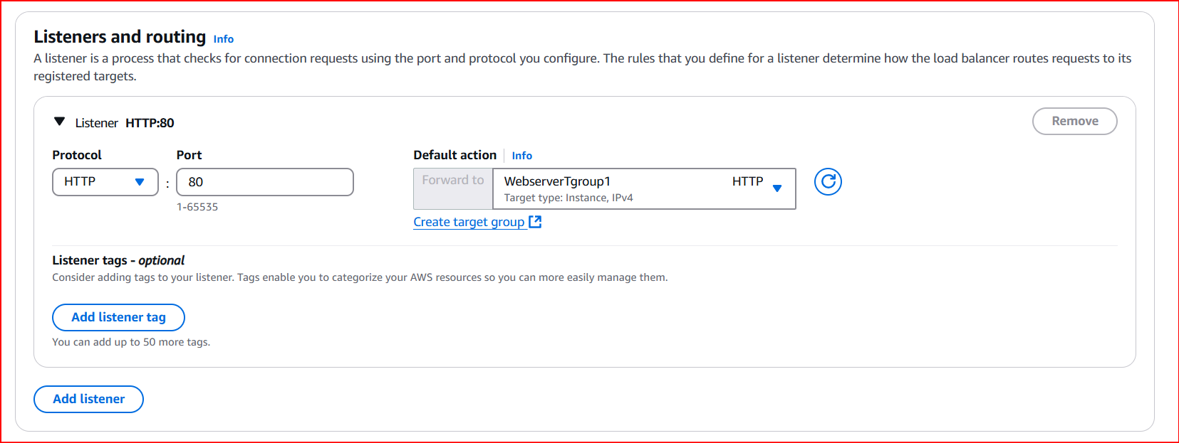

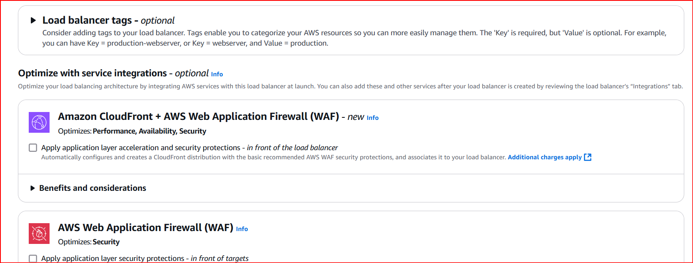

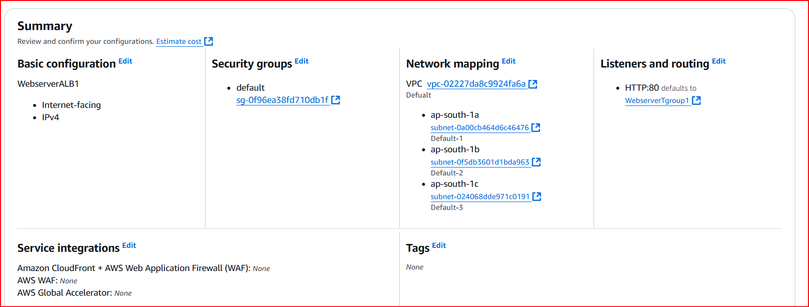

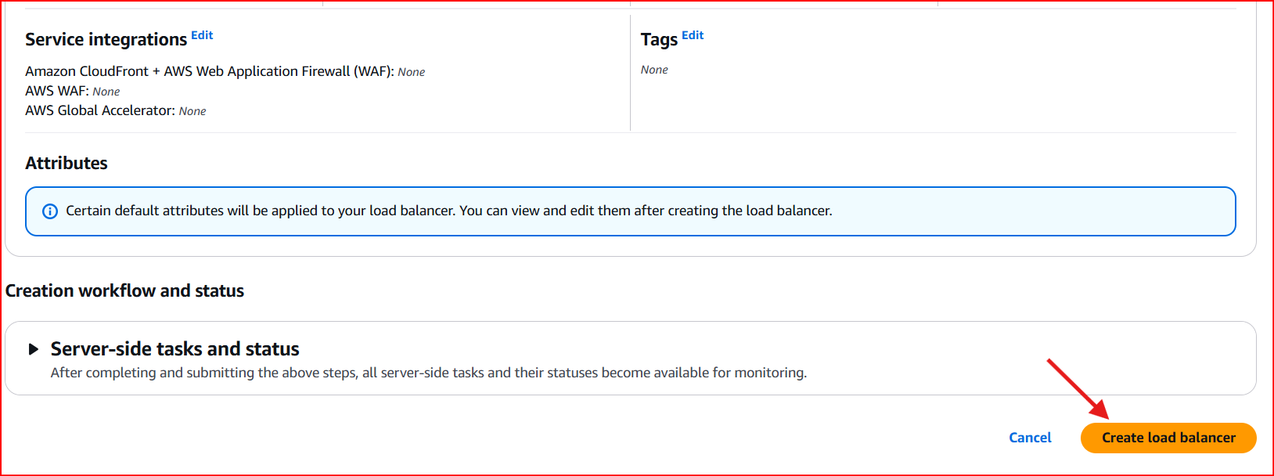

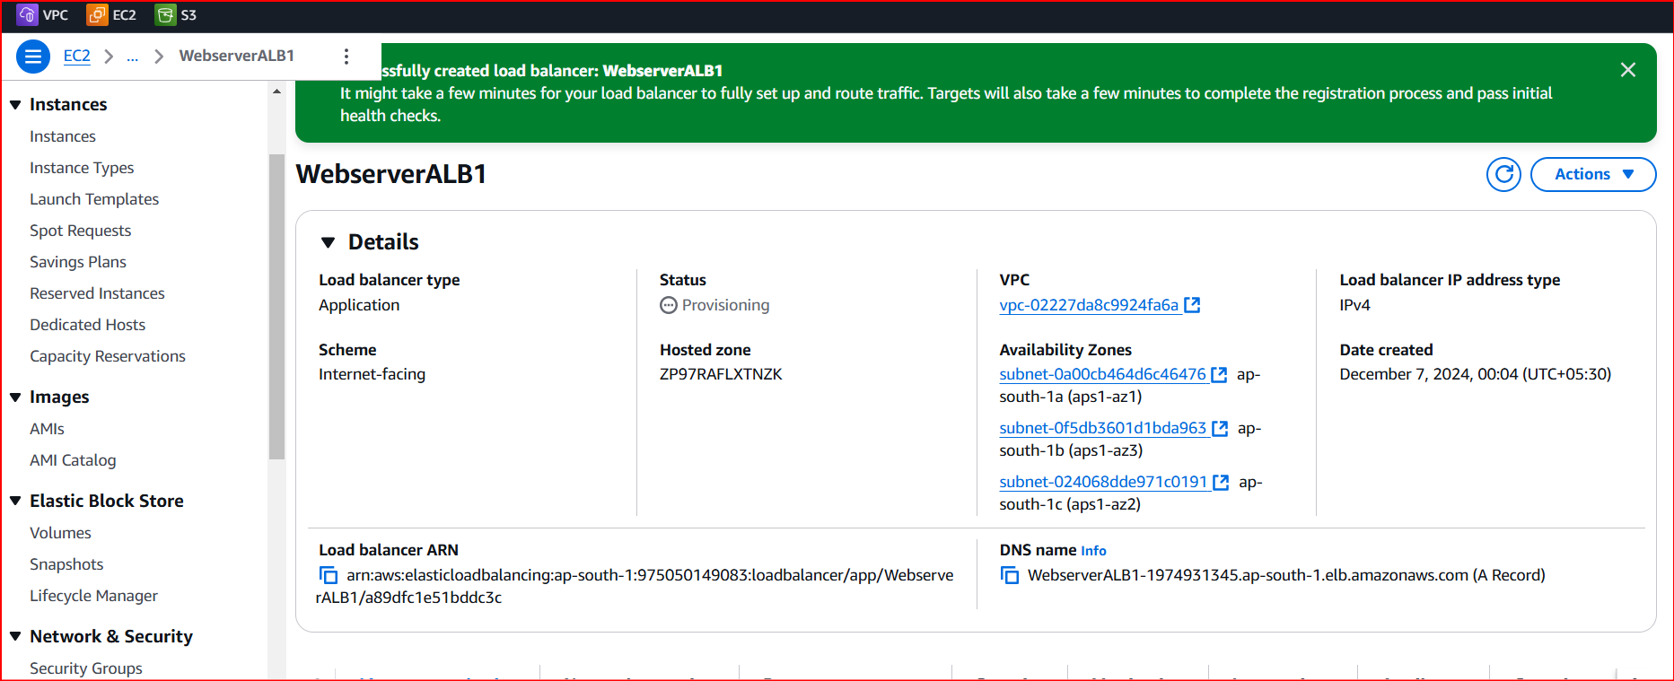

Not routing

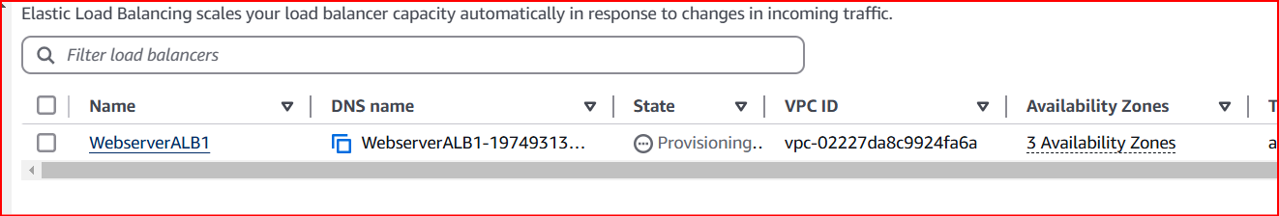

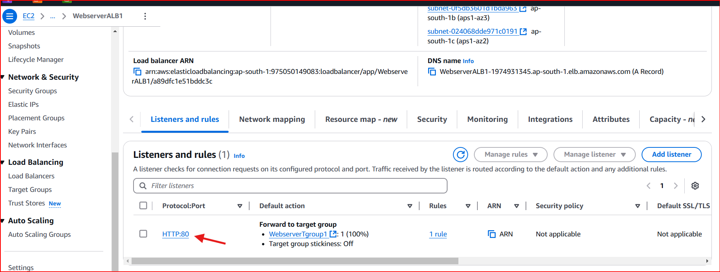

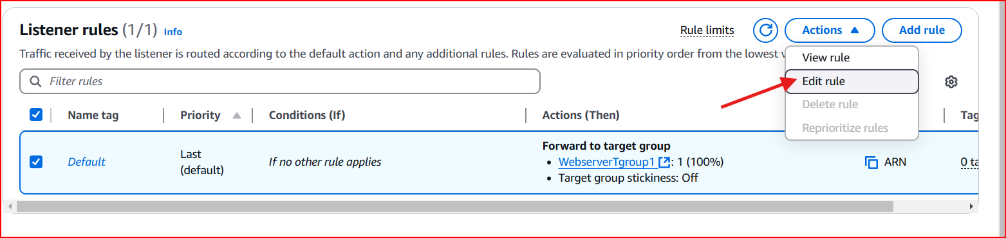

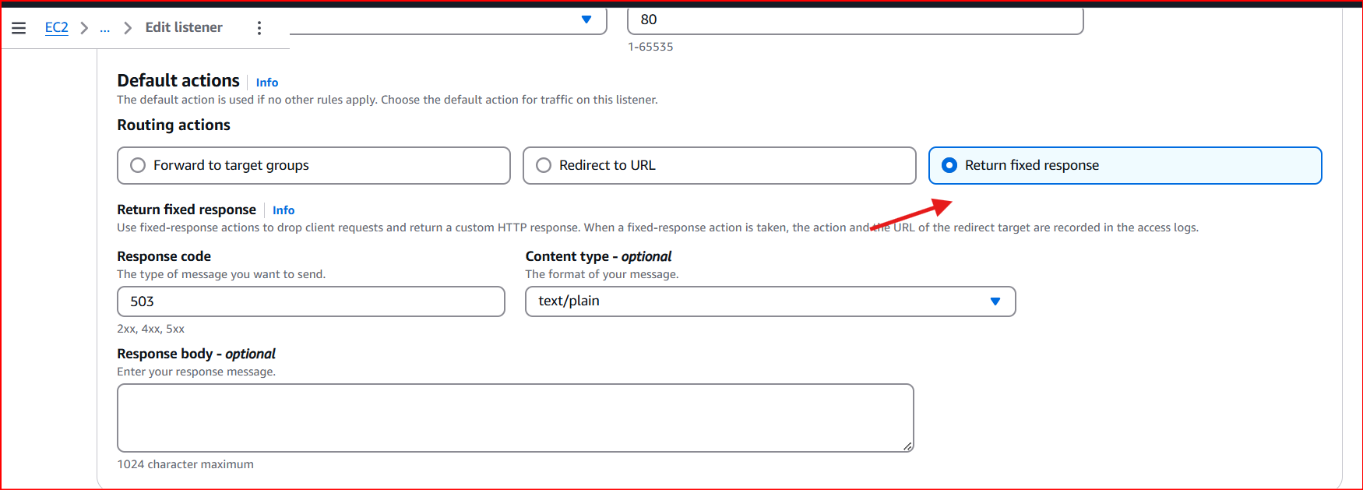

And save

Add new rule

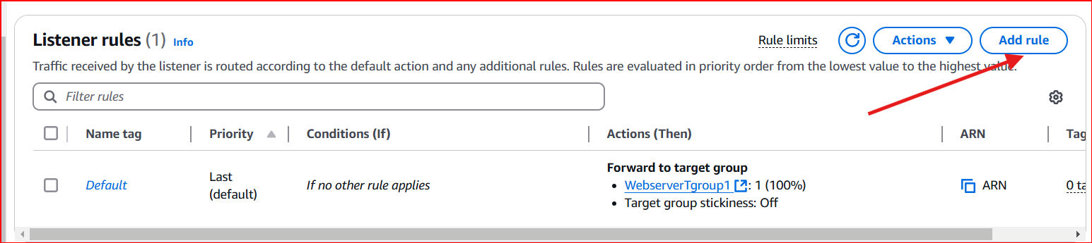

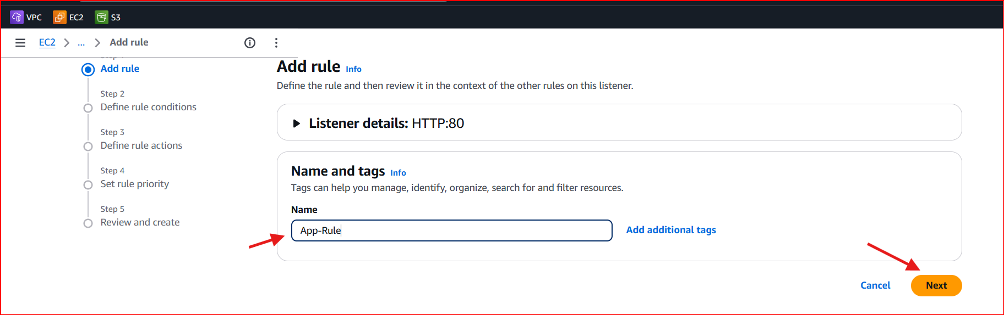

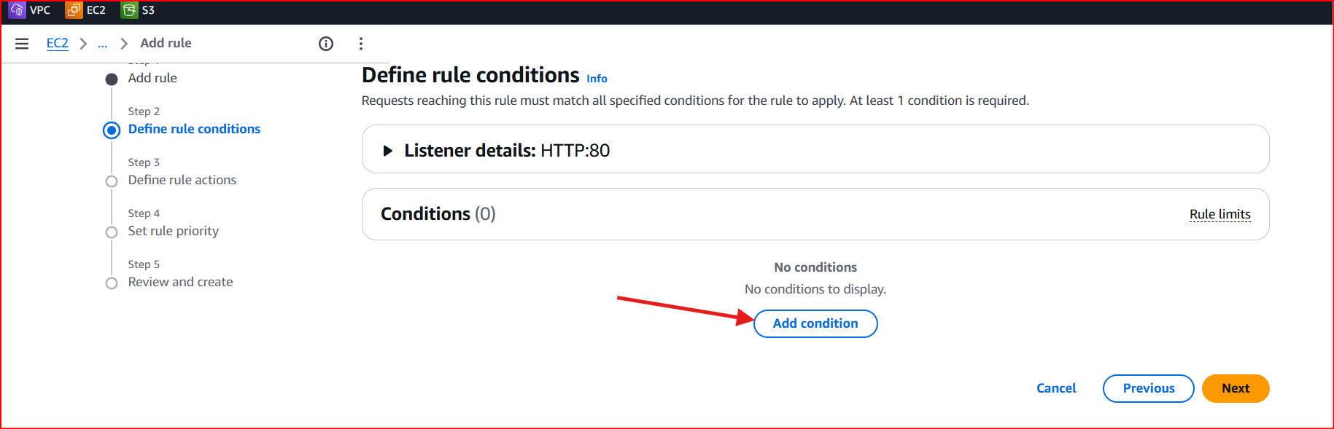

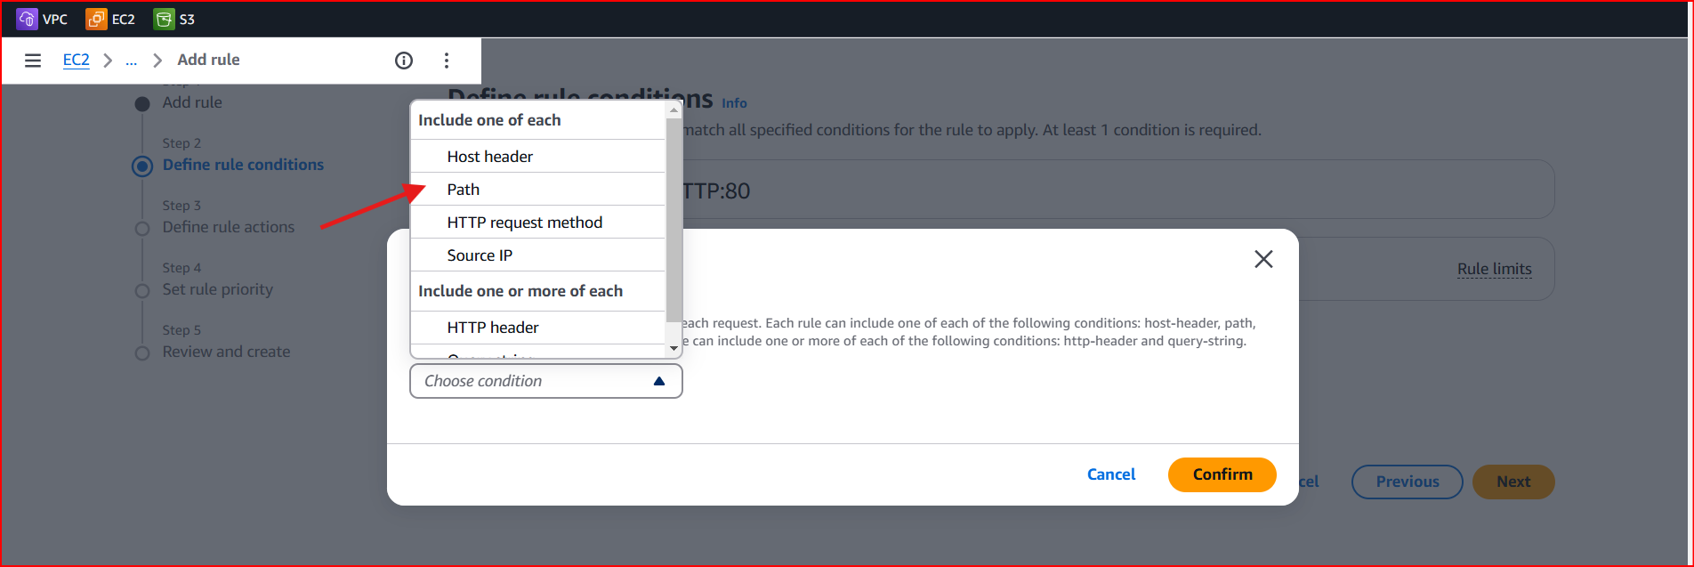

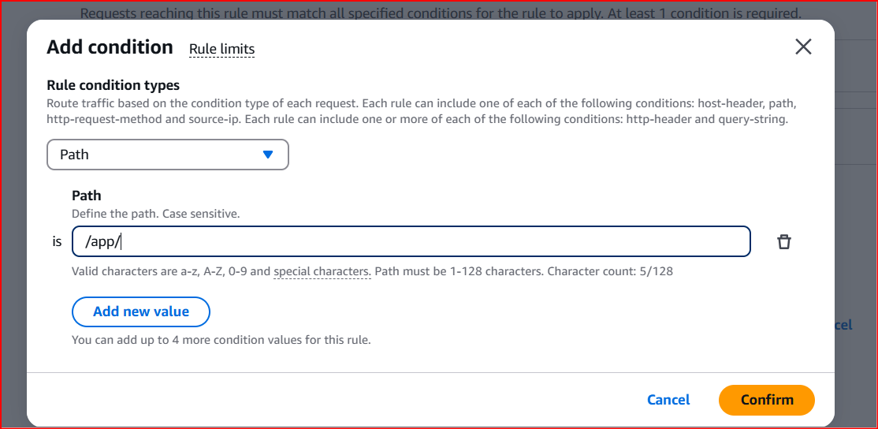

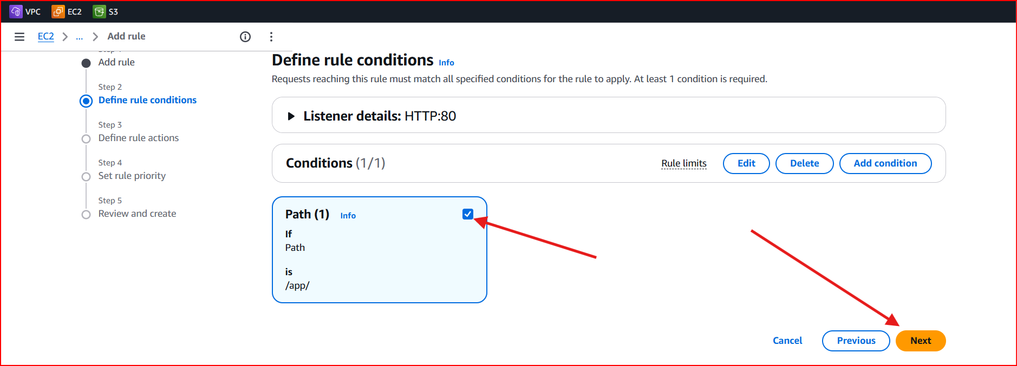

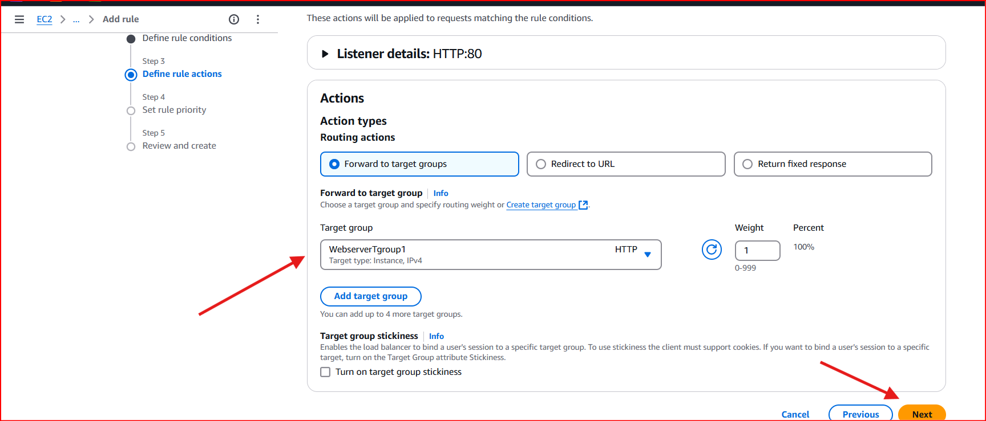

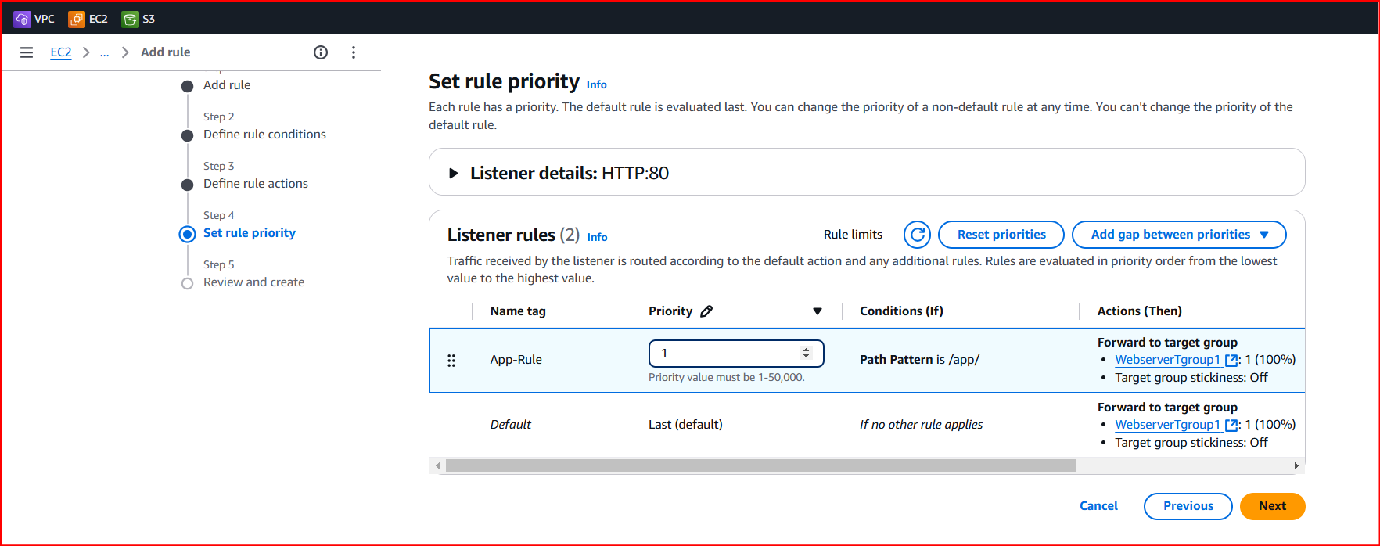

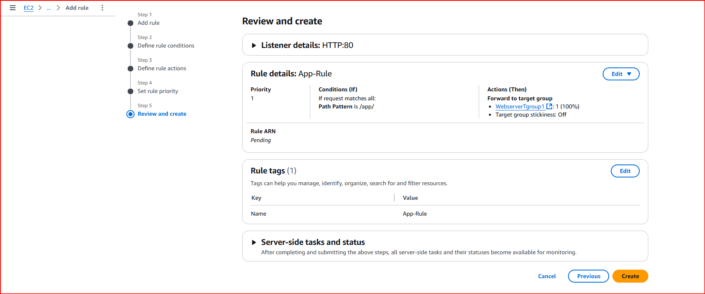

Need another rule

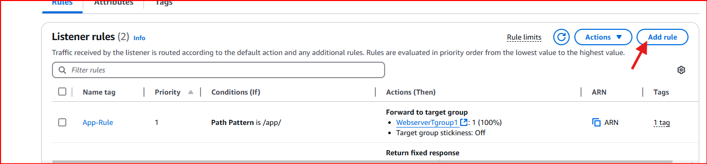

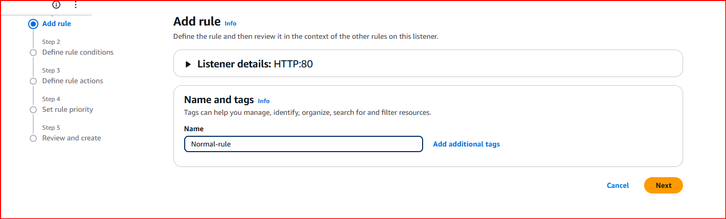

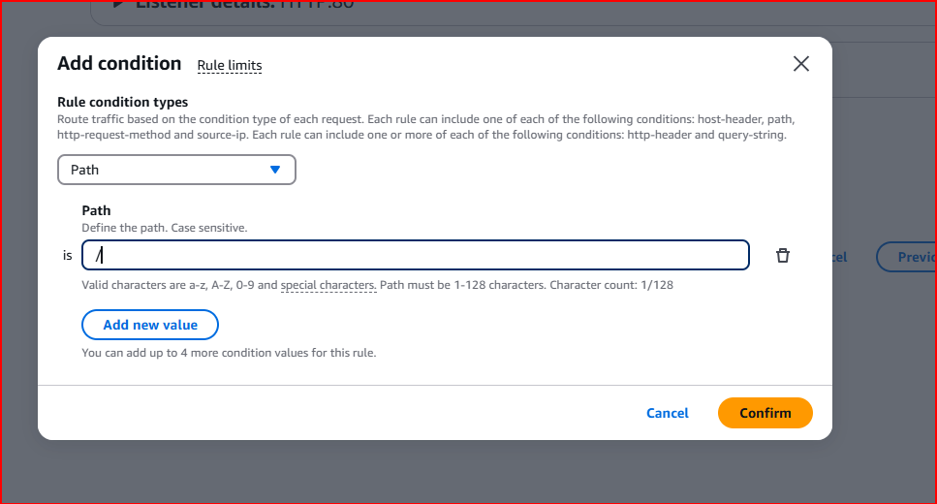

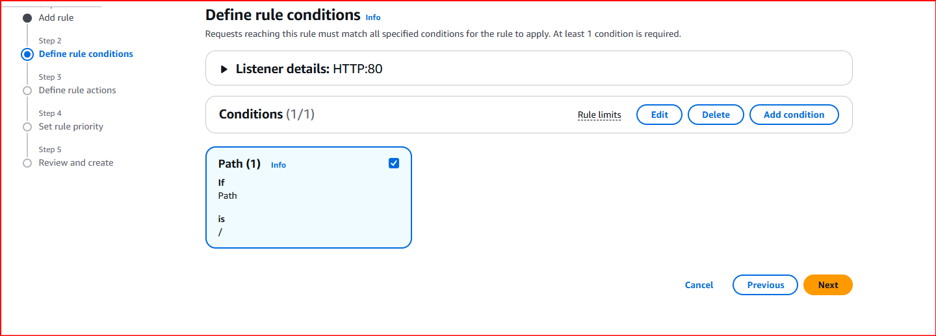

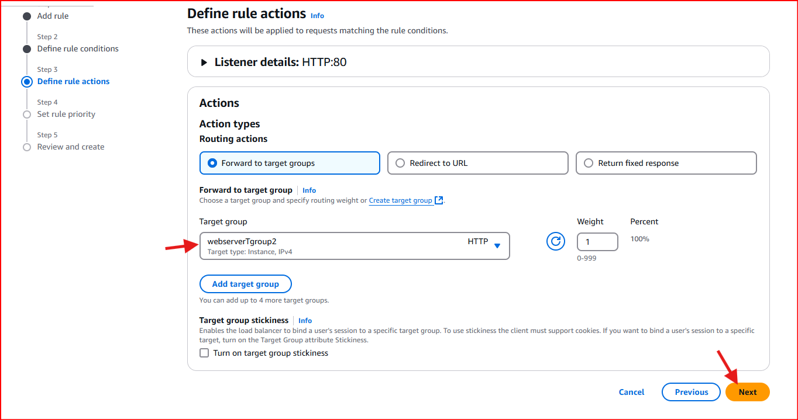

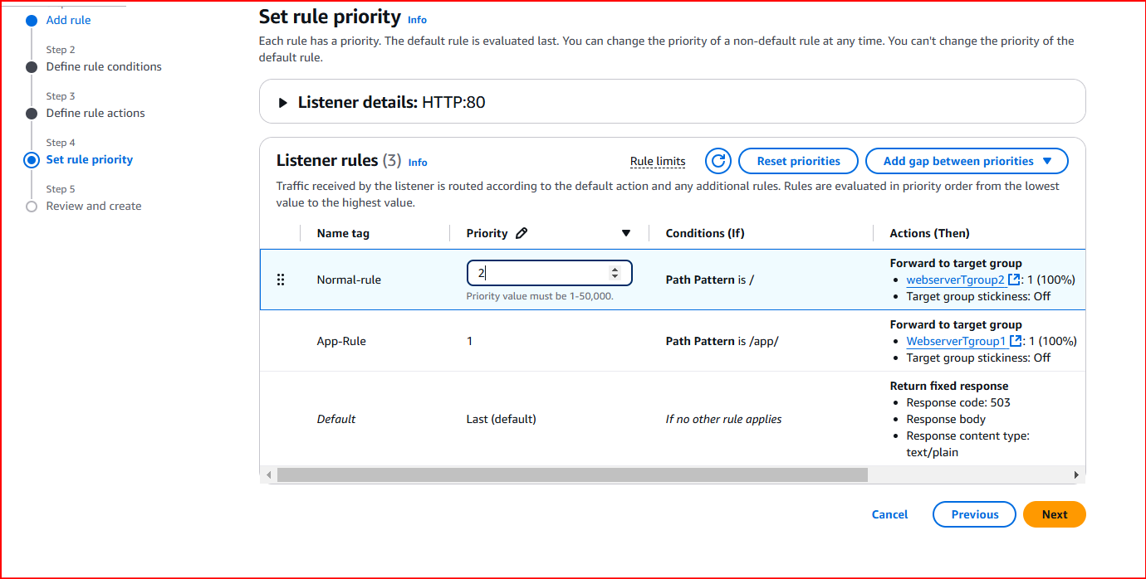

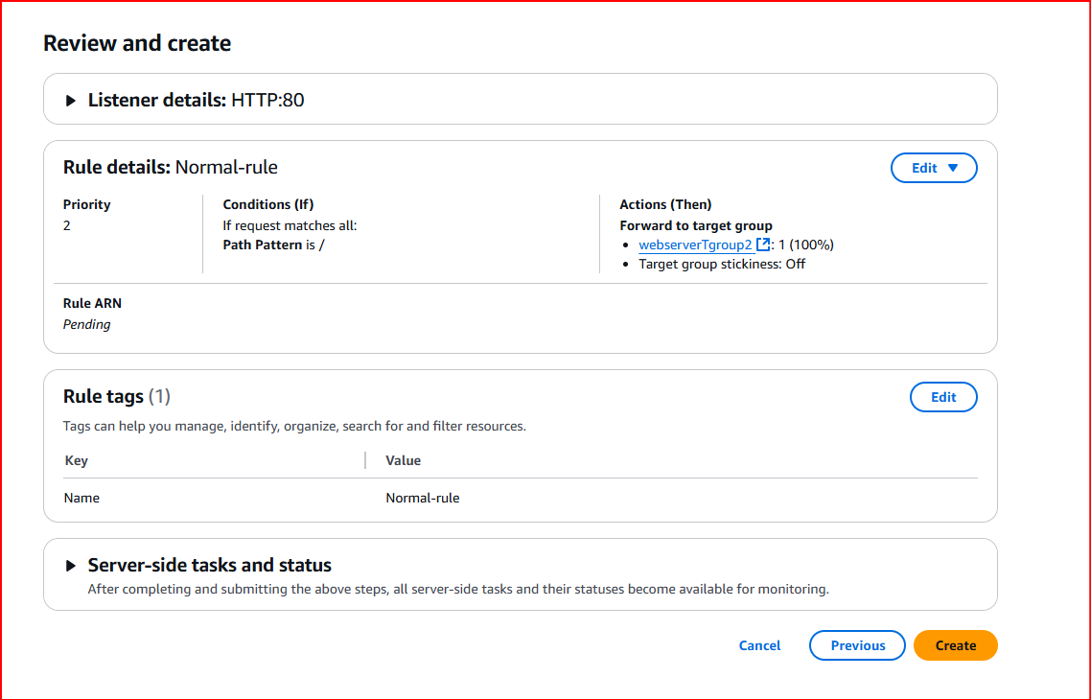

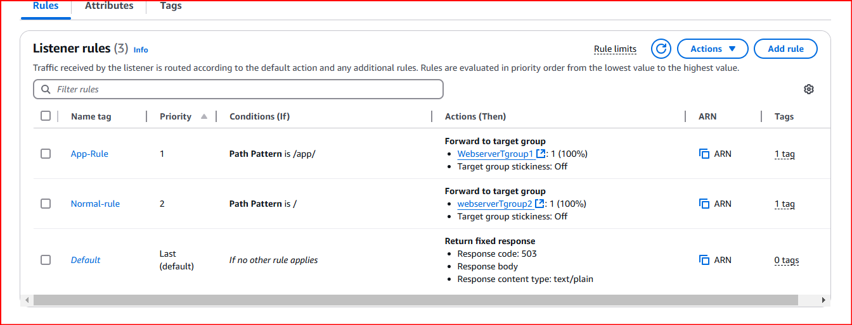

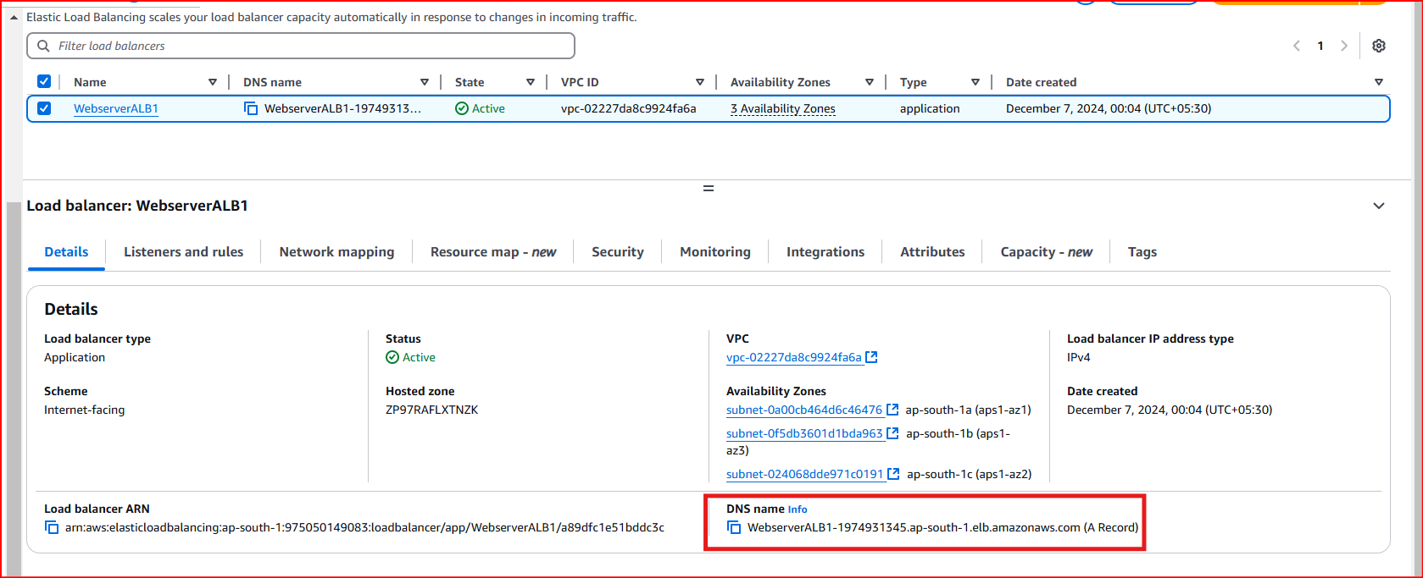

Loadbalancer DNS - WebserverALB1-1974931345.ap-south-1.elb.amazonaws.com

We need to update site update

So go to change to config fill add to dns address

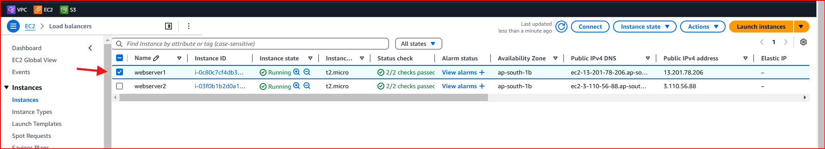

ubuntu@ip-172-31-9-168:~$ cd /etc/apache2/sites-available/

ubuntu@ip-172-31-9-168:/etc/apache2/sites-available$ sudo nano app.conf

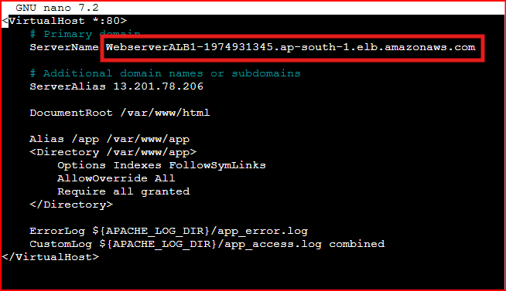

ubuntu@ip-172-31-9-168:/etc/apache2/sites-available$ sudo systemctl reload apache2

